HYDROLOGICAL PROCESSES
Hydrol. Process. (accepted)
manuscript No. 18946
________________________________________________

Comparison of methodological uncertainties within permeability measurements

Nick A Chappell^{1*} and James W Lancaster²

¹ Lancaster Environment Centre, Lancaster University, Lancaster LA1 4YQ, UK
² Ove Arup & Partners International Ltd., Leeds LS9 8EE, UK
________________________________________________

Abstract:

Permeability measurements are critical to the calculation of water-flow within hillslopes. Despite this, errors in permeability measurements are often ignored, and can be very large particularly in disturbance-sensitive gley soils. This work compares the uncertainties associated six field methods of permeametry applied to a gleyed soil in upland Britain. Slug tests, constant-head borehole permeametry, and falling-head borehole permeametry were undertaken on established piezometers. Additionally, ring permeametry and two types of trench test were evaluated.
Method-related uncertainty due to proximity of impeding layers or high sorptivity soils produces under- and over-estimates of permeability by a factor of up to 0.2 and 5, respectively. This uncertainty band is smaller than the observed effects of anisotropy and temporal variability. Had smearing and soil-ring leakage errors not been minimised the methodological uncertainties would have been so large that they would have distorted the true spatial field of permeability and its estimated impact on the balance of vertical and lateral flow.

KEY WORDS borehole, error analysis, gley, hydraulic conductivity, permeability, permeametry

INTRODUCTION

The coefficient of permeability or saturated hydraulic conductivity (K_{s}) is defined using Darcy's Law (Darcy, 1856) as the flow of subsurface water per unit cross-sectional area and per unit hydraulic gradient, and is the most critical parameter governing subsurface water pathways (Zaslavsky and Sinai, 1981; Rogers et al., 1985). Despite this importance, we are becoming increasingly aware that even local measurements of permeability can be difficult to make with accuracy, particularly in disturbance-sensitive gleyed, organic or swelling soils (Hemond and Goldman, 1985; McKay et al., 1993; Chappell and Ternan, 1997; Bagarello et al.. 1999; Sherlock et al., 2000). Moreover, Sherlock et al. (1995, 2000), Brooks et al. (2004) and Chappell and Sherlock (2005) have shown that systematic errors in K_{s} measurements have a large impact on our calculation of the dominant direction of subsurface water-flow. For example, subsurface systems dominated by vertical flow can appear to be dominated by lateral flow where systematic errors in K_{s} measurements differentially affect each soil horizon (Sherlock et al., 2000). Clearly, assessment of technique error should be a precursor to the analysis of the spatial variability of permeability across hillslopes (Chappell and Ternan, 1992). In comparison to precision/random errors, quantification of these systematic errors in permeametry can be difficult (Chappell and Ternan, 1997) and require sensitivity analysis of the component variables (e.g., soil moisture, head), hypothetical calculations, and comparison of different field and numerical methods applied to the same test hole or adjacent soil cores.
This study has sought to quantify key systematic errors associated with the use of six widely used field methods for measuring soil permeability, together with ten associated analytical techniques. All tests are undertaken within disturbance-sensitive gley soils of an experimental watershed in upland Britain. To show the magnitude of both over-estimation and under-estimation errors, each uncertainty is presented primarily as an error factor (ε_{f}):

$ε_{f}=\left(\frac{x_{\text{meas}}}{x_{\text{best}}}\right)$ [1]

where x_{meas} is the measured estimate of the permeability and x_{best} is the best estimate of the permeability (Bagarello et al., 1999; Kumar et al., 2005), rather than as a percentage uncertainty (Chappell and Ternan, 1997). Thus, a three orders of magnitude under-estimate of K_{s} is shown as 0.001 ε_{f}, while a three orders of magnitude over-estimation of K_{s} is shown as 1000 ε_{f}. The uncertainties related to the specific methods were then compared with the measurement uncertainty arising from temporal changes and spatial variability within the best K_{s} data.

SITE CONDITIONS

All tests were undertaken within a 4 ha tributary area (Figure 1) of the 1 km² Greenholes Beck experimental catchment in the uplands of Northwest England, United Kingdom (Lancaster, 1999). The stream gauging structure and raingauge for this tributary area are located at 54.064º North and -2.658º East. All soils tested were classified as Humic Gleysol (FAO-UNESCO, 1990), which is equivalent to the Cambic Stagno-Humic Gley of the Wilcocks series in the English system (Jarvis et al., 1984) or Humaquept in the USDA soil taxonomy (Soil Survey Staff, 1999; Landon, 1991). In England and Wales, these soils are very extensive covering 30 % of the landscape (Avery et al. 1974). Locally, the soils have an Ah horizon (0-20 cm), a Bg horizon (20-50 cm), and a BCg (50-100 cm) with a predominantly silt loam texture (Lancaster, 1999). The soils are derived from glacial till deposited on a Claughton Shale bedrock (Brandon, 1992) and are covered by heath moorland dominated by Molina spp. grass.

FIELD PERMEAMETRY METHODS

A large range of field methods is available for K_{s} assessment (Boersma, 1965; Hendrickx, 1990; Paige and Hillel, 1993) though site conditions often preclude the practical use of certain methods. Within upland Britain, the high rainfall and slowly permeable soils mean that saturated conditions are often found close to the ground surface allowing permeability tests beneath the water-table to be undertaken. Such tests include slug tests (Bouwer, 1989) and trench bailing tests (Cedregen, 1967). Although the majority of the piezometers installed in transects within the Greenholes Beck sub-catchment (Figure 1) show high water-tables some soil horizons are only infrequently saturated making them more amenable to tests such as ring permeametry (Talsma, 1960). While some permeametry methods are applicable over a greater range of conditions, consideration should be given to the sensitivity of each method to the magnitude of systematic errors (Sherlock et al., 2000). In this study, the errors associated with six field methods for determining permeability and ten associated analytical solutions were compared. These methods comprise of three techniques using existing piezometers, namely constant-head and falling-head permeametry and slug tests (Talsma and Hallam, 1980; Bouwer, 1989; Philip, 1993), two methods using existing trenches, namely trench bailing and percolation tests (Cedregen, 1967; Picornell and Guerra, 1992), and one method using soil cores, namely ring permeametry (Talsma, 1960; Chappell and Ternan, 1997).

1. Slug tests

Slug tests are carried out on individual piezometers, and require the water-level within the piezometer (i.e., head) to be either increased (falling-head test) or decreased (rising-head test) to a new level (Bouwer, 1989). In this study, falling-head tests were undertaken and the results analysed using: (a) the Bouwer and Rice (1976) method, and (b) the Hvorslev (1951) method modified for piezometers with closed bases (British Standards Institution, 1983). All of the piezometers installed had 10 to 20 cm screen lengths and 5.0 cm diameter holes including the gravel pack. Preferential flow of water along the outer walls of the piezometers was minimised by incorporating a 10-20 cm deep bentonite seal above the gravel pack (Lancaster, 1999). Slug tests were undertaken on 153 piezometers.

2. Constant-head borehole permeametry

A common method used to determine permeability in initially unsaturated soil is constant-head borehole permeametry (CHBP). This technique involves the maintenance of a constant-level of water in a borehole, and is the basis for the commonly used Guelph Permeameter technique (Reynolds and Elrick, 1985; Bell and Schofield 1990). CHBP is normally used within newly excavated auger-holes (Bonell et al., 1983; Reynolds and Elrick, 1985; Chappell et al., 1996), however, with this study all tests were undertaken on existing piezometers. The constant-head borehole permeameter used follows the design of Talsma and Hallam (1980), modified with a smaller diameter outer tube to allow insertion in to the piezometer cases. As CHBP analyses assume that percolation occurs along the entire depth of water within a borehole, all CHBP tests were undertaken with the water-level maintained at the top of the open/screened section. Soil near the piezometer screens was pre-wetted with several litres of water prior to the test to reduce the effect of capillarity or ‘sorptivity’. CHBP tests were performed on 29 piezometers. The original solution of Talsma and Hallam (1980) was used to analyse the test data. Because this solution does not include the possible sorptivity effects of the unsaturated zone away from the borehole (Stephens and Neuman, 1982ab; Philip, 1985; Bell and Schofield, 1990) alternative solutions given by: (i) Reynolds et al. (1985), (ii) Philip (1985) and rearranged by Bell and Schofield (1990), and (iii) Stephens et al. (1987) were also applied.

3. Falling-head borehole permeameter

The falling-head borehole permeameter (FHBP) method of Philip (1993) was used on 39 piezometers within the Greenholes Beck tributary area. The analytical solution presented in Philip (1993) was modified slightly to account for the gravel pack around our piezometers (Lancaster, 1999).

4. Trench bailing tests

In order to derive values of permeability at a slightly larger scale, four of five trenches 1.6 m long, 0.2 m wide and 0.7 m deep excavated at the top of the piezometer transects (Figure 1) were subjected to trench bailing experiments. The trenches were open to the soil over their entire depth so the solution for an uncased hole given in Cedregen (1967) was used. The radius term within Cedregen (1967) was derived from the area of a circle equivalent to the area of the rectangular trench floor.

5. Trench percolation tests

Trench percolation tests were carried out on three of five trenches, two the same as for the bailing tests, and K_{s} was derived by the analytical method presented in Picornell and Guerra (1992).

6. Ring permeametry

The ring permeameter technique is the only core-based technique used within the Greenholes Beck sub-catchment, and involved the excavation of large (7,200 cm³) undisturbed cylindrical soil cores, followed by the subsequent measurement of the amount of water required to maintain a constant-head on the top of the core (Talsma, 1960; Bonell et al., 1983; Chappell and Ternan, 1997). This method uses much larger cores than typical laboratory permeameters (British Standards Institution, 1990) to reduce the errors arising from disturbance and edge effects during ring insertion (Hill and King, 1982; Rogers and Carter, 1987). Chappell and Ternan (1997) have presented a full error analysis of this method that can be used as a reference for the in situ borehole methods. In contrast to all of the other field methods of K_{s} determination used, the ring permeametry technique determines the soil permeability in only one direction, normally vertical permeability.
The impact of changing water temperature and hence viscosity on permeability test values should be taken into account (Loague 1992). Thus, all field measurements of permeability were corrected to those that would have been recorded at an ambient temperature of 20°C (Bonell et al., 1983; Chappell and Ternan, 1997).

METHODOLOGICAL UNCERTAINTIES

Evaluation of the six field techniques plus the different ways of analysing the same test results has allowed direct quantification of five sources of method-related uncertainty within K_{s} values for the gleyed soil tested. Tests designed to quantify the errors associated with smearing and coring disturbance were not undertaken at Greenholes, as these effects had been minimised within our procedures. As previous studies have shown that the uncertainties arising from these two errors are very large in certain circumstances (Chappell and Ternan, 1997), they were included in this results discussion as a reference. The methodological uncertainties quantified are due to: (i) smearing, (ii) coring disturbance, (iii) nonlinearities in test data, (iv) error in depth to an underlying impermeable layer, (v) soil moisture error during test, (vi) analytical approximation in the borehole methods, and (vii) anisotropy. As noted earlier, all uncertainties are presented in factors, where the best estimate of the K_{s} values multiplied by the Error Factor ε_{f} gives the observed value.

Uncertainty due to smearing

Augering within soils, particularly in gleyed soils, forms a 'skin' of smeared clay blocking structural pores and thus artificially reducing permeability. Chappell and Ternan (1997) showed that the smearing of the auger-hole walls prior to standard CHBP tests can lead to the under-estimation of actual soil permeability by up to a factor of 0.001 to 0.0001 (Kanwar et al., 1987; Paige and Hillel, 1993; Chappell and Ternan, 1997; Sherlock et al., 1995, 2000). Rather than use newly prepared auger-holes for our tests we used piezometers (incorporating gravel packs) and trenches installed over one year prior to testing. This unconventional use of established piezometers and trenches for all in situ tests allowed installation-related smearing to be cleared by many natural exchanges of soil-water across piezometer screens / trench walls prior to permeability testing. As a result, no smearing errors are expected in the piezometer and trench data from the Greenholes Beck sub-catchment.

Uncertainty due to coring disturbance

Inserting rings into the ground to isolate a soil sample can produce systematic errors within subsequent core-based permeametry (Hill and King, 1982; Rogers and Carter, 1987; Chappell and Ternan, 1997). Chappell and Ternan (1997) demonstrated that K_{s} values could be over-estimated by a factor of 66 to 6,557 for intermediate to slowly permeable soils, where the prescribed ring permeametry method was not followed. Poor practice typically results from uneven hammering for the ring into the ground, which creates a gap between the metal ring and the soil sample, which is then not sealed. Within the Greenholes Beck catchment, all rings were inserted by vertical hammering centrally on a plate placed over the ring (Chappell and Ternan, 1997). Large gaps between soil and ring were avoided, and the contact between the ring and soil was sealed by tamping clay. As result no over-estimation of permeability due to leakage between ring and soil should be observed.
Insertion of metal rings into layered and compacted stony sediments can open the structure of the whole soil core, and thereby lead to over-estimation of the K_{s} by more than a factor of 100 (Chappell, unpublished data). The regolith produced by solifluction processes present in many parts of western England typically comprises of layered and compacted stony sediments (Harris, 1987). The gley soil and regolith tested within the Greenholes Beck catchment did not comprise of such sediments and was, therefore, not subject to these errors.

Uncertainty due to nonlinearities in test data

Most of the responses during the slug tests conformed well to straight lines on semi-log plots of ln(head) plotted against time (Bouwer and Rice, 1976). Figure 2 shows that incorporation of nonlinear sections of these data would have led to errors of – 80 % to + 230 % or a factor of 0.55 to 3.3 error in the permeability results. For the other five tests, small nonlinear sections of the ln(head) versus time relation (for falling-head tests) or head versus time relation (for constant-head tests) were excluded from the analyses, and complete data sets were excluded where the majority of the relation was non-linear.

Uncertainty due to error in depth to impermeable layer

The Bouwer and Rice (1976) method of slug test analysis requires definition of the depth of the piezometer base to an underlying impermeable layer. For our piezometer geometries, if the piezometer is incorrectly assumed to lie directly upon an impermeable layer the K_{s} value calculated would be over-estimated by + 30 to + 40 % or a factor of 1.30 to 1.46 (Figure 3). The slug test solution of British Standards Institution (1983), a modified form of the Hvorslev (1951) equation, does not require specification of the underlying impermeable layer and is, therefore, not sensitive to uncertainty in its quantification.

Uncertainty due to soil moisture error during borehole testing

The FHBP solution of Philip (1993) requires an estimate of the difference between the volumetric moisture content at the start of the test and the porosity (i.e., term θ₁-θ₀). For the FHBP tests at Greenholes Beck, neutron moderation measurements (Institute of Hydrology, 1981) gave a mean value of θ₁-θ₀ of 0.16 cm³ cm⁻³ for piezometers within the Ah horizon and 0.15 cm³ cm⁻³ for piezometers in the Bg horizon. Consequently, an error of +0.01 cm³ cm⁻³ in the volumetric water content (Institute of Hydrology, 1981) would have given an over-estimation of K_{s} by a factor of 1.1 (Lancaster, 1999).
The same soil moisture data were used to estimate K_{s} from the CHBP tests using the Reynolds et al. (1985) equation. The sorptivity values derived from the soil moisture data had a geometric mean of 0.76 m⁻¹ and a variance of 0.33. If the true sorptivity is greater by one standard deviation than an estimate based on the mean, the CHBP method under-estimates K_{s} by a factor of 0.8. Where true sorptivity is smaller by one standard deviation, the method over-estimates K_{s} by a factor of 1.3 (Lancaster, 1999).

Uncertainty due to analytical approximation in the borehole methods

The Hvorslev (1951) analysis is considered by Keller et al. (1989) more reliable than the Bouwer and Rice (1976) method, as it better allows for both vertical and horizontal flow, a critical issue for piezometers with the short screen lengths used within our study. Figure 4a shows a comparison of the Bouwer and Rice (1976) and Hvorslev (1951) derived K_{s} values for slug tests performed on 120 piezometers, together with a line equal to unity. It can be seen that the Bouwer and Rice (1976) method consistently under-estimates K_{s} (by up to a factor of 0.1) compared to the Hvorslev (1951) method, although the difference between the two methods is not consistent, being dependent on the configuration of the local flow system. The difference in estimated K_{s} values is not, however, due to an incorrect assumption that the piezometer base rests on an impermeable layer used in the Bouwer and Rice (1976) analysis, as this would lead to an over-estimation of K_{s}.
As many of our piezometers have a screen length and effective radius of similar size, the CHBP equations of Talsma and Hallam (1980), Philip (1985) and Stephens et al. (1987) are likely to produce less accurate permeability values in comparison to the solution of Reynolds et al. (1985). Differences in the K_{s} values between these analytical methods, therefore, are shown with reference to the Reynolds et al. (1985) solution (Figure 4b). The solution of Talsma and Hallam (1980) consistently over-estimates K_{s} by a factor of 1.6 (for most permeable soils) to 4.3 (for least permeable soils). This over-estimation is expected as the solution neglects the effect of capillarity on the flow from boreholes whilst the other three solutions take account of the effects of capillarity. The Stephens et al. (1987) solution mostly over-estimates K_{s} by a factor of 1.7 to 3, while the Philip (1985) solution is most similar, under-estimating K_{s} by a factor of 0.05 to 0.6 (Figure 4b).
Assuming that the modified analytical solutions of Hvorslev (1951), Reynolds et al. (1985) and Philip (1993) give the least uncertainty in the slug, CHBP and FHBP results, respectively, we now compare the results of these three field methods. Only two piezometers were available for comparison of the CHBP, FHBP and slug test results on the same piezometers and these results are shown in Table 1. Within the subsoil (piezometer T1.2 at 28 cm depth) the largest K_{s} values were only a factor of 1.2 larger than the smallest, while in the topsoil (piezometer T1.1. at 14 cm depth) the difference is a factor of 4.5. A further six piezometers had both FHBP and slug tests and showed a difference of a factor of 0.2 to 6.2 (mean 1.41: Table 1), while 12 piezometers were subjected to both CHBP and FHBP tests and showed a difference of a factor of 0.1 to 5.3, but with a mean of only 1.04 (Table 1). Comparison of the statistical distributions of the FHBP and slug test data shows that they produce equivalent statistical distributions at the 0.95 confidence level using T-Tests (Wrinkler and Hays, 1975) applied to the log normalised data (Table 2). The CHBP data could not be normalised by a natural log transform, so a Wilcoxon Signed-Rank Test (Wrinkler and Hays, 1975) was undertaken to compare the untransformed means of the CHBP and FHBP data (Table 2). This statistical test showed that these field techniques similarly produce equivalent distributions at the 0.95 confidence level (Table 2). From the comparisons of the statistical distributions, we can conclude that any systematic over-estimation or under-estimation in the modified Hvorslev (1951) solution for slug tests, the Reynolds et al. (1985) solution of CHBP tests and modified Philip (1993) solution of FHBP tests is too small to affect the statistical distributions.

Uncertainty due to unmeasured anisotropy

Figure 5 shows borehole-derived K_{s} profiles along Transect 1 and by ring permeametry at three slope positions less than 2 m away. The ring permeametry results are a factor of 0.5 to 200 different from the borehole results (Figure 5). As our borehole tests were undertaken on long-established piezometers and thus not subject to acknowledged smearing problems (see Sherlock et al., 2000), the differences may be due to the fact that our ring permeametry provides estimates of only vertical K_{s} while the borehole-based methods produce estimates of the K_{s} tensor predominantly in the horizontal direction. Morphological observations indicate that macropores within the Humic Gleysol at Greenholes Beck were predominantly aligned in a vertical direction (Lancaster, 1999), and thus anisotropy would be expected.
The four K_{s} values from the trench percolation tests are an average of a factor of 37 larger than the mean of the slug test values derived from the two 70 cm deep piezometers adjacent to each trench (Lancaster, 1999). The mean head in the trenches during the percolation tests was 21 cm so the ratio of the wetted wall area to the floor area was 2.4. With the slug testing of the piezometers, this ratio was only 0.01. Consequently, a greater proportion of the percolation would be vertical with these trench tests in comparison to the slug tests on piezometers. Again, a greater vertical compared to lateral permeability (due to a predominantly vertical orientation of desiccation cracks) would explain the lower K_{s} values derived from the borehole slug tests. Trench 3 and 4 had K_{s} values derived from both percolation and bailing tests. The percolation tests give K_{s} values a factor of 1.9 (Trench 3) and 4 (Trench 4) greater than those from the bailing tests. These differences could be due to the reduced proportion of vertical to lateral flow during bailing tests because of the lower head of approximately 7 centimetres. Alternatively, the higher water-levels in the percolation tests mean that the K_{s} values are affected by flow in to higher strata (i.e., 49 to 63 cm), which are often more permeable (Chappell and Ternan, 1992).
It should be noted that the K_{s} values for each strata derived by ring permeametry (Figure 5) and trench tests are all within the range of the K_{s} values for each strata for the whole dataset of borehole values.

Summary of methodological uncertainty

Chappell and Ternan (1997) assessed the methodological uncertainties arising from all precision and systematic errors associated with the prescribed use of the ring permeameter. They found a ±11 % total uncertainty with the ring permeameter (Chappell and Ternan, 1997) which is equivalent to an error factor of 0.90 to 1.11 ε_{f} . Using the results from the comprehensive error analysis of Chappell and Ternan (1997) as a reference, some of the systematic errors associated with the borehole methods were considerably larger than this range. Incorrect use of non-linear sections of ln(head) versus time relation (for falling-head tests) or head versus time relation (for constant-head tests), gave an error factor of 0.55 to 3.3 with the slug test data. Such an error is likely to be produced by incorrect use of nonlinear portions of test data from CHBP, FHBP, trench and ring permeametry (Chappell and Ternan, 1997), but can be avoided by omitting such data.
As the standard ring permeametry method requires tests on cores excavated from the ground, the method is not sensitive to the effects of proximity to impeding layers or high sorptivities of nearby soils. The Rice and Bouwer (1976) solution of slug test data is shown to be sensitive to an accurate knowledge of the proximity to an impeding layer, with errors of a factor of up to 1.3 to 1.46 generated where these depths are inaccurate. Where such depth data are not known, then the solution of Hvorslev (1951) can be used, but this does not mean the presence of an impeding layer just below the test hole will not affect the flow geometry during a slug, CHBP or trench percolation test and, thereby lead to an under-estimation (ε_{f} < 1) of the K_{s} . The effect of high and uncertain sorptivity of nearby soils was examined with the CHBP and FHBP tests. These were found to produce errors of a factor of 0.8 to 1.3 with the Reynolds et al. (1985) solution of the CHBP tests and a factor of 1.1 with the modified Philip (1993) solution of the FHBP tests. Larger sorptivity related uncertainties of a factor of 0.05 to 0.6, 1.7 to 3 and 1.6 to 4.3 were seen with the Philip (1985), Stephens (1987), and Talsma and Hallam (1980) solutions to the CHBP data. The impeding layer and sorptivity effects, therefore, give larger uncertainties in the borehole and trench data in comparison to the total errors of ring permeametry techniques (i.e., 0.90 to 1.11 ε_{f}).
Critically, sorptivity and impeding layer uncertainties are insignificant when compared to the published under-estimation of K_{s} by a factor of 0.001 to 0.0001 due to smearing of new auger-holes or over-estimation of K_{s} by a factor of 66 to 6,557 due to core-ring leakage (Chappell and Ternan, 1997). As all of our borehole and trench tests were undertaken on holes installed more than one year prior to the test, this smearing error was not present. Similarly, all ring permeametry tests were undertaken on cores sealed against soil-ring leakage. Consequently, uncertainties due to errors in soil moisture quantification, unmeasured impeding layer effects and analytical approximation were within the range of a factor of 0.2 and 5, which is equivalent to ± 400 % uncertainty or ± half an order of magnitude (Chappell and Ternan, 1992, 1997). Where the best analytical solutions were used (i.e., Hvorslev, 1951; Reynolds et al., 1985; Philip, 1993), then uncertainties remain within the range of ± 400 % uncertainty for individual boreholes or trenches, and reduce to less than ± 40 % (or a factor of 0.71 to 1.4), where the centroid of data distributions are compared.
The effect of allowing only one-dimensional vertical flow into the soil during our ring permeametry becomes an important ‘error’ when anisotropy is large and no attempt is made to measure separately the lateral and vertical components of permeability. Lateral as well as vertical permeability should and can be determined using ring permeametry (Chappell and Ternan, 1997). Anisotropy affects borehole and trench test results, but the lateral and vertical components are difficult to quantify separately.

UNCERTAINTY FROM TEMPORAL VARIABILITY

Two periods of CHBP testing were carried out on the shallow Transect 1 piezometers (Figure 1), one during very dry antecedent conditions in the summer and the other during more typical, wetter antecedent conditions (Lancaster, 1999). From the results presented in Figure 6a it is noticeable that for most piezometers the wet-period determined K_{s} values were typically lower than the values determined in the dry-period by up to a factor of 0.02. The lower wet period K_{s} values are most likely due to closure of desiccation cracks with prolonged exposure to moisture (Lin et al., 1998; Bagarello et al., 1999).
A total of fifteen 7,200 m³ cores in three soil profiles were measured using the ring permeameter close to piezometer Transect 1. Three of the cores were extracted during dry conditions and subject to between 4 and 7 repeat ring permeametry tests within one day. The core taken from the near-surface (0-10 cm) showed a decrease in K_{s} by a factor of 0.02 (Figure 6b) due to closure of desiccation cracks with the maintenance of saturated conditions. Figure 6b also shows that that the temporal change in permeability or ‘non-stationarity’ (Zheng et al., 2000) reduces with soil sampled from deeper in the soil profile due to their lower levels of organic matter (Hemond and Goldman, 1985).
Temporal reductions in topsoil K_{s} by up to a factor of 0.02 (or a – 4,900 % change) with closure of desiccation cracks are considerably larger than the methodological uncertainties associated with the best borehole techniques (± 400 %) or ring permeametry (± 11 %). Uncertainties associated with the degree of openness of desiccation cracks within topsoils (McKay et al., 1993) means that this non-stationarity must be quantified where infiltration-excess (Ellis et al., 2006) or very shallow lateral flow (Bonell and Gilmour, 1978; Chappell et al., 1990) pathways are dominant.

METHODOLOGICAL UNCERTAINTY vs SPATIAL VARIABILIY

A key issue for those using permeability data should be whether the errors associated with the methods give uncertainties larger than the true spatial variability and deterministic patterns in the permeability (Chappell and Ternan, 1992, 1997; Sherlock et al., 1995, 2000). Where the methodological uncertainties are larger than the spatial uncertainty or deterministic patterns in K_{s} values, then little physical interpretation of the spatial variability data should be attempted (Chappell and Sherlock, 2005). To estimate the statistical and vertical distribution of K_{s} within the Greenholes Beck sub-catchment we use data derived primarily from slug tests applied to 117 piezometers, plus CHBP tests applied to a 10 piezometers and FHBP tests to a 7 piezometers where no reliable slug test data were available. Permeability values were then derived by the modified Hvorslev (1951), Reynolds et al. (1985) and modified Philip (1993) analytical techniques.

Statistical distribution

Many studies have found that K_{s} frequency distributions are skewed, so a range of transforms were applied to the Greenholes data to identify the underlying statistical distribution (Table 3). Kolmogorov-Smirnov Tests (Wrinkler and Hays, 1975) applied to transformed data indicated that a log transform best normalises the dataset (Table 3). Many studies (e.g., Nielsen et al., 1973; Chappell and Franks, 1996; Chappell et al., 1998) have similarly observed that K_{s} follows a log-normal distribution, though other frequency distributions can be observed (e.g., Elsenbeer et al., 1992; Chappell et al., 1996). A geometric mean is the most appropriate mean for a log-normally distributed population, and for the Greenholes Beck K_{s} data for the Humic Gleysol to a depth of 190 cm it is 0.12 cm/hr. The variance is 10.2, which corresponds to a Coefficient of Variation (CV) of 570 %. A similarly high CV for the K_{s} of a Eutric Cambisol (Chappell and Franks, 1996) and a Haplic Alisol (Chappell et al., 1998) have been found within the 91 ha Slapton Wood Catchment (UK) and 44 ha Baru Catchment (Malaysia), respectively. Box-and-whisker plots (Wrinkler and Hays, 1975) of the statistical distributions of the K_{s} data for each of the five piezometer-transects are shown in Figure 7a. A Wilcoxon (Mann-Whitney) Rank-Sum Test (Wrinkler and Hays, 1975) does, however, indicate that only Transect 3 permeability is statistically different from any other transects (Transect 1 vs 3: Z_{rscritical} = 1.965, Z_{rs} = -2.26; Transect 3 vs 5: Z_{rscritical} = 1.965, Z_{rs} = +2.34).

Vertical (profile) distribution

Soil forming processes affect the changes in K_{s} with depth (Chappell and Ternan, 1992). Typically, a decline in K_{s} with depth is seen (Rogers et al, 1991, Lind and Lundin 1990, Chappell and Ternan, 1992; McKay et al., 1993). Figure 10a shows individual borehole-measured K_{s} values against the depth, and the relationship is best described by a power function (r² = 0.43). Figure 7b shows the layer-specific, geometric mean K_{s} value against depth, and these data are similarly described by the power function:

K_{s}(d) = K*.e^{-f} [2]

where K* = 6.48 cm/hr, f = 0.0875 and d = depth (cm), or:

$K_{s}(d)=k_{}d^{−n_{k}}$ [3]

with K* = 16,377 cm/hr and n_{k} = 3.24 (r² = 0.96). Permeability, therefore, increases by a factor of 550 from the base of the solum (70 cm depth) to the ground surface (Figure 7c).

Comparison with methodological uncertainty

The Coefficient of Variation in the borehole K_{s} data of 570 % is larger than the methodological uncertainties associated with ring permeametry (± 11 %) and the best borehole techniques (± 400 %); consequently, the Coefficient of Variation in the K_{s} data used for the statistical analysis, results from a combination of spatial variability in K_{s} and errors within and between our best methods. The uncertainty about the power relationship between depth and individual K_{s} values of some ± 1000 %, or errors of a factor of 0.01 to 100, or ± 2 orders of magnitude (Figure 7b) is much larger than the methodological uncertainty. Thus the spatial variability in K_{s} within one soil horizon is much larger than uncertainties within our best methods. Had our borehole methods been subject to the worst smearing-related errors of up to 0.001 to 0.0001 or soil-ring leakage errors of a factor of 66 to 6,557, then the variations within our data might have been largely a function of errors in the methodology.

CONCLUSIONS

There are four key conclusions arising from this study examining the uncertainties associated with six field permeametry methods.

1. Previous studies have shown that the largest errors associated with permeametry arise from: (a) smearing during augering prior to borehole permeability tests, and (b) the creation of a gap between soil core and metal ring during coring prior to core-based permeametry (Chappell and Ternan, 1997). Smearing of clay- and silt-rich soils can lead to under-estimation of permeability by up to a factor of 0.001 to 0.0001 with tests undertaken directly after augering, while leaving a large gap between the soil and ring within similar soils would lead to over-estimation of permeability by up to a factor of 66 to 6,557 (Chappell and Ternan, 1997). Our borehole techniques (i.e., slug tests, CHBP, FHBP) were undertaken on lined boreholes installed over year prior to testing, so the permeability tests were not subject to smearing errors. Equally, our core-based technique (i.e., ring permeametry) was undertaken on cores where the soil-ring contact was sealed with clay, and thus was not subject to artificial leakage.

2. Most of our error analysis was based on permeability tests applied to the network of 153 boreholes within the Greenholes Beck catchment. Quantifiable uncertainties of a factor of 0.55 to 3.3 arose from using nonlinear sections of ln(head) versus time data for the slug tests. Similar errors would have been produced if the nonlinear portions of the CHBP and FHBP data had been used. When only correct data were used, the largest errors with the borehole methods arose from the effects of the depth to the underlying impermeable strata (by up to a factor of 1.30 to 1.46) and the sorptivity of the soil adjacent to test holes. If the Reynolds et al. (1985) solutions to CHBP tests are considered to best capture the effects of sorptivity, the Talsma and Hallam (1980) solution, which does not include sorptivity effects, may underestimate permeability by up to a factor of 4. All component errors related to these two phenomena were within the range of a factor of 0.2 (i.e., under-estimation) to a factor of 5 (i.e., over-estimation), or ± 400 % uncertainty. Comparison of the best analytical solutions to data from the slug tests, CHBP and FHBP produced differences in permeability values for individual boreholes that were within this same range of a factor of 0.2 to 5, or ± 400 % uncertainty. These errors are larger than those errors previously quantified for ring permeametry of a factor of 0.90 to 1.11 (Chappell and Ternan, 1997). They are, however, much smaller than the errors of up to a factor of 0.001 to 0.0001 (or -10,000 to -100,000 %) that arise from borehole smearing or errors of up to a factor of 66 to 6,557 (+6,549 to +655,569 %) due to soil-ring leakage.

3. Wetting of the Ah horizon of the gley at the Greenholes site when initially desiccated resulted in the gradual closure of cracks and a reduction in permeability by a factor of 0.02 (or a – 4,900 % change). While these effects reduced with depth, within the Ah and upper Bg horizons the temporal changes in (temperature-standardised) permeability are much larger than our methodological uncertainty of a factor of 0.2 to 5. Consequently, temporal changes or non-stationarity in permeability should be characterised routinely in those soils that are sensitive to change, notably topsoil that is gleyed, organic rich or contains swelling clays. Trench tests and ring permeametry can give permeability values a factor of 37 or even 200 greater than borehole tests. These differences may be due to anisotropy in the permeability. As these uncertainties are greater than non-stationarity effects and other potential biases except smearing or coring errors, all permeability measurement exercises should quantify the differences between the vertical and lateral permeability of each strata.

4. The uncertainty of a factor of 0.2 to 5 (± 400 %) with the borehole techniques is smaller than the range in permeability measured for each soil horizon (during wet conditions) which varies by a factor of 0.01 to 100 (or ± 1000 %), and as evidence for this, a power relationship between permeability and depth could be established. Our analysis, however, would indicate that some of the measurement uncertainty relates to methodological uncertainty as well as the true spatial variability. Had the smearing errors and soil-ring leakage errors not been minimised by our procedures then they would have given uncertainties much larger than the true spatial variability in the permeability. This would have made any interpretation of the mean value of permeability, the Coefficient of Variation and depth-related relationships meaningless. This analysis, therefore, provides further justification for error analysis during all permeability testing, the use of only the least error-prone methods, and for a need not to use others data within models where such error analysis is absent. The errors inherent within some permeability tests mean that the risks of misinterpretation of the direction and magnitude of runoff pathways are very high.

Acknowledgements

This research was supported by NERC grant NERC GT4/93/171/P. Mr David Taylor, Mr TA Lye and New World Power Co. Ltd are thanked for access to the Greenholes Beck experimental catchment on Caton Moor. Comments by Dr Amanda Chetwynd and Dr Wlodek Tych (Lancaster University), Dr Tim Atkinson (University of East Anglia) and the two reviewers are gratefully appreciated.

REFERENCES

Avery BW, Findlay DC, Mackney D. 1974 Soil Map of England and Wales. Soil Survey of England Wales: Harpenden.
Bagarello V, Iovino M, Reynolds WD. 1999 Measuring hydraulic conductivity in a cracking clay soil using the Guelph Permeameter. Transactions of the ASAE 42: 957-964
Bell RW, Schofield NJ 1990 Design and application of a constant head well permeameter for shallow high saturated hydraulic conductivity soils. Hydrological Processes 4: 327-342.
Boersma L. 1965. Field measurement of hydraulic conductivity above a water table. In Black CA, Clark DD, Evans JL, White DD, Ensiminge LE (eds.). Methods of Soil Analysis: Part 1. American Society of Agronomy : Madison : 234–252.
Bonell M, Gilmour DA. 1978 The development of overland flow in a tropical rainforest catchment. Journal of Hydrology 39: 365–382.
Bonell M, Gilmour DA, Cassells DS. 1983 A preliminary survey of the hydraulic properties of rainforest soils in tropical north-east Queensland and their implications for the runoff process. In de Ploey J. (ed.). Rainfall simulation, runoff and soil erosion. Catena Supplement 4 : 57-78.
Bouwer H. 1989 The Bouwer and Rice slug test – an update. Groundwater 27: 304-309.
Bouwer H, Rice RC. 1976 A slug test for determining hydraulic conductivity of unconfined aquifers with completely or partially penetrating wells. Water Resources Research 12: 423-428.
British Standards Institution. 1983 Test pumping water wells, BS3616. British Standards Institution : London.
British Standards Institution. 1990. British Standard methods of test for soils for engineering purposes, Part 6: Consolidation and permeability tests in hydraulic cells and with pore pressure measurement, BS1377. British Standards Institution : London : 61 pp.
Brooks ES, Boll, J McDaniel PA. 2004 A hillslope-scale experiment to measure lateral saturated hydraulic conductivity. Water Resources Research 40: art No. W04208.
Brown DL, NarasimhanTN, Demir Z. 1995 An evaluation of the Bouwer and Rice method of slug test analysis. Water Resources Research 31: 1239-1246.
Cedregen R. 1967 Seepage, drainage and flow nets. Wiley : New York.
Chappell NA, Ternan JL. 1992 Flow path dimensionality and hydrological modelling. Hydrological Processes 6: 327-345.
Chappell NA, Ternan JL. 1997 Ring permeametry: design, operation and error analysis. Earth Surface Processes and Landforms 22: 1197-1205.
Chappell NA, Franks SW. 1996 Property distributions and flow structure in the Slapton Wood catchment. Field Studies 8: 559-578.
Chappell NA, Sherlock M. 2005 Contrasting flow pathways within tropical forest slopes of Ultisol soil. Earth Surface Processes and Landforms 30: 735-753.
Chappell, N.A., Ternan, J.L., Williams, A.G., and Reynolds, B. 1990 Preliminary analysis of water and solute movement beneath a coniferous hillslope in mid-Wales, UK. Journal of Hydrology 116: 201-215
Chappell NA, Stobbs A, Ternan JL, Williams AJ. 1996 Localised impact of Sitka Spruce (Picea sitchensis (Bong.) Carr.) on soil permeability. Plant and Soil 182: 157-169.
Chappell NA, Franks SW, Larenus J. 1998 Multi-scale permeability estimation for a tropical catchment. Hydrological Processes 12: 1507-1523.
Darcy H. 1856 Les fontaines publiques de la ville de Dijon. Dalmont : Paris.
Ellis TW, Leguédois DS, Hairsine PB, Tongway DJ. 2006 Capture of overland flow by a tree belt on a pastured hillslope in south-eastern Australia. Australian Journal of Soil Research 44: 117–125.
Elsenbeer H, Cassel K, Castro J. 1992 Spatial analysis of soil hydraulic conductivity in a tropical rainforest catchment. Water Resources Research 28: 3201-3214.
FAO-UNESCO. 1990 Soil Map of the World: Revised Legend. FAO : Rome.
Harris C. 1987 Solifluction and related periglacial deposits in England and Wales. In Boardman J. (ed.). Periglacial processes and landforms in Britain and Ireland. Cambridge University Press : Cambridge : 209-223.
Hemond HF, Goldman, JC. 1985 On non-Darcian water flow in peat. Journal of Ecology 73: 579-584.
Hendrickx JMH, 1990 Determination of hydraulic properties. In Anderson MG, Burt TP (eds.). Process Studies in Hillslope Hydrology. John Wiley and Sons : Chichester : 43–92.
Hill RL, King LD. 1982 A permeameter which eliminates boundary flow errors in saturated hydraulic conductivity measurements. Soil Science Society of America Journal 46: 877–880.
Hvorslev MJ. 1951 Time lag and soil permeability in ground-water observations. Bulletin No. 36, Waterways Experiment Station. US Corps of Engineers : Vicksburg.
Institute of Hydrology, 1981 User’s Handbook for the Institute of Hydrology Neutron Probe System. Institute of Hydrology report 79. Institute of Hydrology : Wallingford.
Jarvis RA, Bendelow UC, Bradley RI, Carroll DM, Furness RR, Kilgour INL, King SJ. 1984 Soils and their use in Northern England. Rothamsted Experimental Station : Harpenden.
Kanwar RS, Rizvi HA, Ahmed M, Horton R Jr, Marley SJ. 1987 A comparison of two methods for rapid measurement of saturated hydraulic conductivity of soils, In Proceedings of the Third International WorKshop on Land Drainage. Ohio State University, Department of Agricultural Engineering : Columbus (Ohio) : G35–53.
Keller CK, van der Kamp G, Cherry JA. 1989 A multiscale study of the permeability of a thick clayey till. Water Resources Research 25: 2299-2317.
Kumar CS, Arul AJ, Singh OP, Rao KS. 2005 Reliability analysis of shutdown system. Annals of Nuclear Energy 32: 63-87.
Landon JR. 1991 Booker Tropical Soil Manual. A Handbook for Soil Survey and Agricultural Land Evaluation in the Tropics and Subtropics. Longman Technical: New York.
Lancaster JW. 1999 Multi-scale estimation of effective permeability within the Greenholes Beck catchment. Unpublished PhD thesis. University of Lancaster : Lancaster.
Lin HS, McInnes KJ, Wilding LP, Hallmark CT. 1998 Macroporosity and initial moisture effects on infiltration rates in Vertisols and vertic intergrades. Soil Science 163: 2-8.
Lind BB, Lundin L. 1990 Saturated hydraulic conductivity of Scandinavian tills. Nordic Hydrology 21: 107-118.
Loague K. 1992 Soil water content at R-5. Part 1. Spatial and temporal variability. Journal of Hydrology 139: 233-251.
McKay LD, Cherry JA, Gillham RW. 1993 Field experiments in a fractured clay till 1. Hydraulic conductivity and fracture aperture. Water Resources Research 29: 1149-1162.
Nielsen DR, Biggar JW, Erh KT. 1973 Spatial variability of field-measured soil water properties. Hilgardia 42: 215-259
Paige GB, Hillel D. 1993 Comparison of three methods for assessing soil hydraulic properties. Soil Science 155: 175–189.
Philip JR. 1985 Approximate analysis of the borehole permeameter in unsaturated soil. Water Resources Research 21: 1025-1033
Philip JR. 1993 Approximate analysis of falling-head lined borehole permeameter. Water Resources Research 29: 3763-3768.
Picornell M, Guerra A. 1992 A comparison of field and laboratory measurements of hydraulic conductivity. In Nielsen DM, Sara MN. (eds.). Current practices in ground water and vadose zone investigations. ASTM STP 1118. American Society For Testing Materials : Philadelphia.
Reynolds WD, Elrick DE. 1985 Measurement of field-saturated hydraulic conductivity, sorptivity and the conductivity-pressure head relationship using the Guelph Permeameter. In Proceedings of the National Water Well Conference on Characterization and Monitoring of the Vadose (Unsaturated) Zone, November 1985. Denver, Colorado.
Reynolds WD, Elrick DE, Clothier BE. 1985 The constant head well permeameter: effect of unsaturated flow. Soil Science 139: 172-180.
Rogers JS, Carter CE. 1987 Soil core sampling for hydraulic conductivity and bulk density. Soil Science Society of America Journal 51: 1393–1394.
Rogers CCM, Beven KJ, Morris EM, Anderson MG. 1985 Sensitivity analysis, calibration and predictive uncertainty in the Institute of Hydrology Distributed Model. Journal of Hydrology 81: 179-191.
Rogers JS, Selim HM, Carter CE, Fouss JL. 1991 Variability of auger hole hydraulic conductivity values for a Commerce silt loam. Transactions ASAE 34: 876-883.
Sherlock MD, Chappell NA, Greer T. 1995 Tracer and Darcy-based identification of subsurface flow, Bukit Timah forest, Singapore. Singapore Journal of Tropical Geography 16: 197-215.
Sherlock MD, Chappell NA, McDonald JJ. 2000 Effects of experimental uncertainty on the calculation of hillslope flow paths. Hydrological Processes 14: 2457-2471.
Soil Survey Staff. 1999 Soil Taxonomy: A basic system of soil classification for making and interpreting soil surveys. Second edition. USDA, US Government Printing Office: Washington DC.
Stephens DB, Lambert K, Watson D. 1987 Regression models for hydraulic conductivity and field test of the borehole permeameter. Water Resources Research 23: 2207-214.
Stephens DB, Neuman SP. 1982a Vadose zone permeability tests – steady-state results. Journal of the Hydraulics Division-ASCE 108: 640-659.
Stephens DB, Neuman SP. 1982b Vadose zone permeability tests - unsteady-flow. Journal of the Hydraulics Division-ASCE 108: 660-677.
Talsma T. 1960 Comparison of field methods for measuring hydraulic conductivity. In Fourth Annual Congress. International Commission on Irrigation and Drainage : Madrid : C11, 145-156.
Talsma T, Hallam PM. 1980 Hydraulic conductivity measurement of forest catchments. Australian Journal of Soil Research 30: 139-148.
Wrinkler RL, Hays WL, 1975 Statistics: Probability, Inference and Decision. Second Edition. Holt, Rinehart and Wiston : New York.
Zaslavsky D, Sinai G. 1981. Surface hydrology: IV. Flow in sloping, layered soil. Journal of the Hydraulics Division, ASCE 107 (HY1): 53-64.
Zheng S, Corbett PWM, Ryseth A, Stewart G. 2000 Uncertainty in well test and core permeability analysis: a case study in fluvial channel reservoirs, northern North Sea, Norway. AAPG Bulletin 84: 1929-1954.
FIGURES

Figure 1. The 4 ha Greenholes Beck tributary area (54.065º North, -2.658º East) in Northwest England, United Kingdom. The catchment divide and stream is shown with a broad solid line, the elevation contours with a fine solid line, and the piezometer transects (e.g., Transect 1 or ‘T1’) with broken lines.
Figure 2. Errors in K_{s} estimation by Bouwer and Rice (1976) solution of slug test data where non-linear as well as linear elements of the ln(head) curve are used.
Figure 3. Effect of uncertainty in the depth to an impermeable layer with the Bouwer and Rice (1976) solution of slug test data.
Figure 4. The effect of different analytical solutions of K_{s} from slug tests and constant-head borehole permeametry (CHBP). Subplot (a) shows a comparison of Hvorslev (1951) and Bouwer and Rice (1976) analytical solutions to slug test data (including a 1:1 line), and (b) the uncertainty in estimates of K_{s} using the Talsma and Hallam (1980), Stephens et al, (1987), and Philip (1985) solutions to CHBP results in comparison to those produced by the Reynolds et al. (1985) solution.
Figure 5. Comparison of ring and borehole derived estimates of K_{s.} at three different slop locations along Transect 1 (see Figure 1). Bars indicate the range of depth around the mid-point over which K_{s} was measured.
Figure 6. Effect of non-stationarity in permeability (after correction for viscosity effects) from: (a) CHBP tests on shallow piezometers (where 1:1 line is for dry-period values), and (b) repeat ring permeametry tests method at an initially dry mid-slope position. Units are log(cm/hr).
Figure 7. The spatial variability in a dataset of K_{s.} values derived from the modified Hvorslev (1951) solution of slug tests data, Reynolds et al. (1985) solution of CHBP data and modified Philip (1993) of FHBP data. Subplot shows: (a) Box-and-Whisker plots of the natural log transformed data from each piezometer transect 1 to 5, (b) variation in individual K_{s} values with depth, and (c) variation in layer-specific, geometric mean K_{s} with depth.

Figure 1
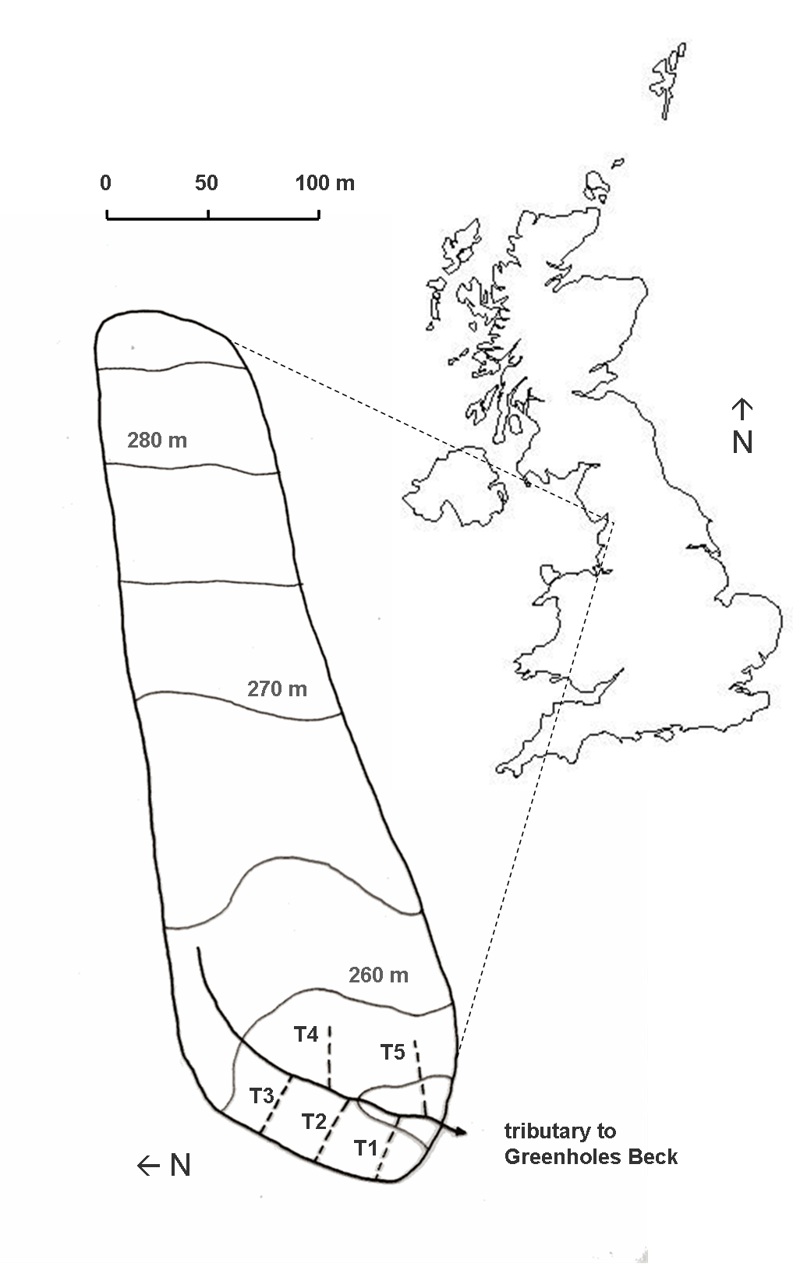

Figure 2

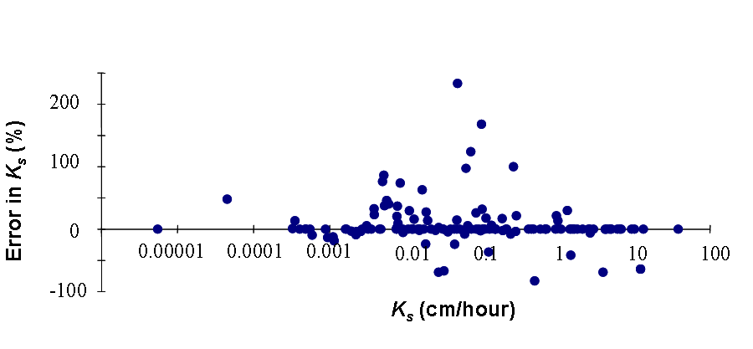

Figure 3

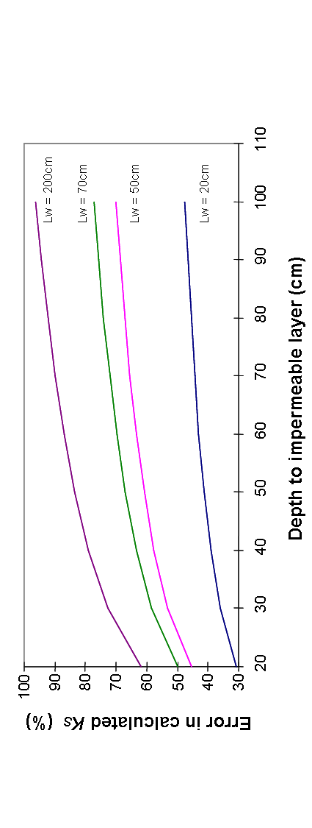

Figure 4a

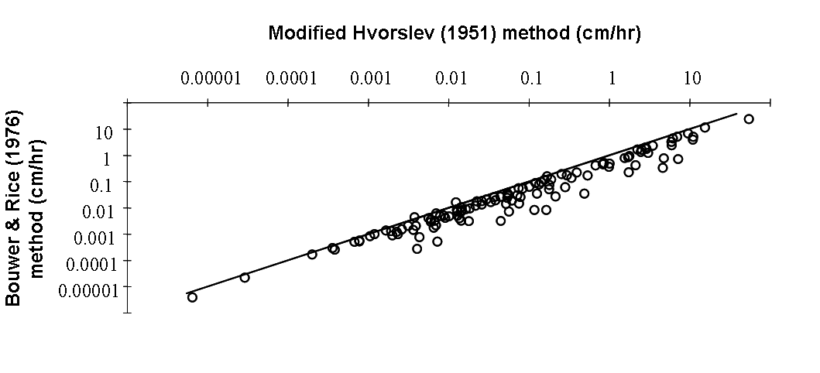

Figure 4b

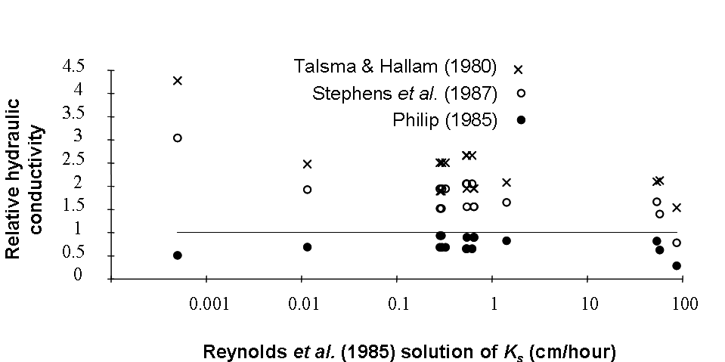

Figure 5

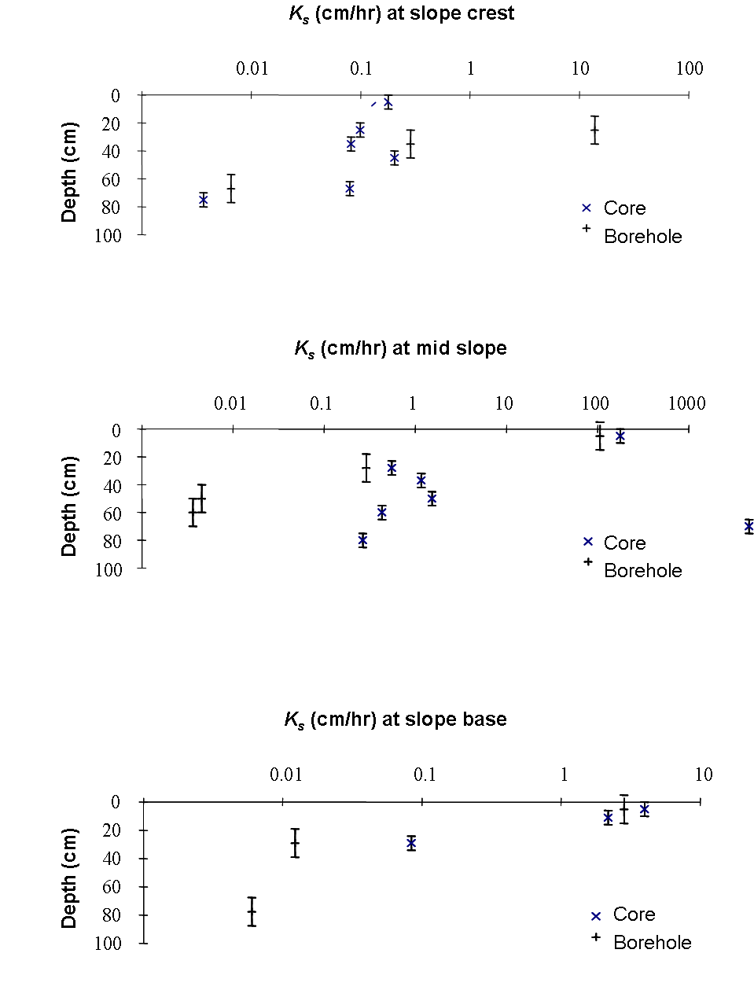

Figure 6a

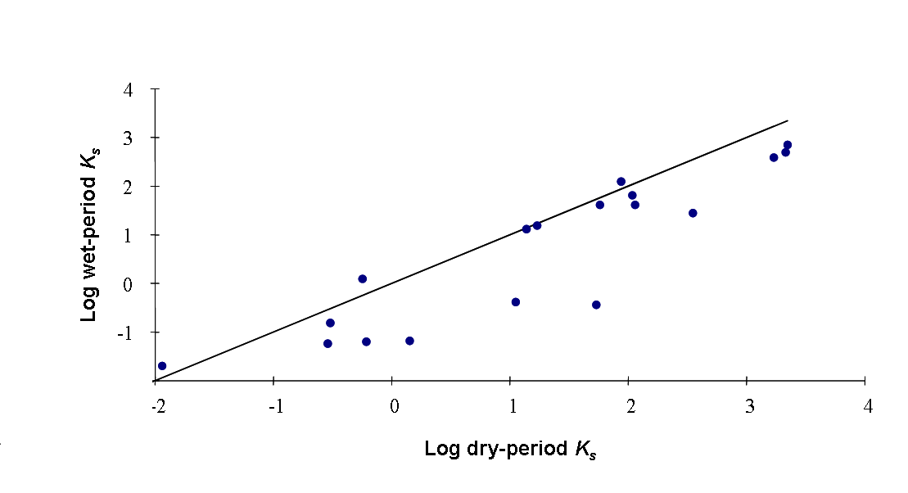

Figure 6b

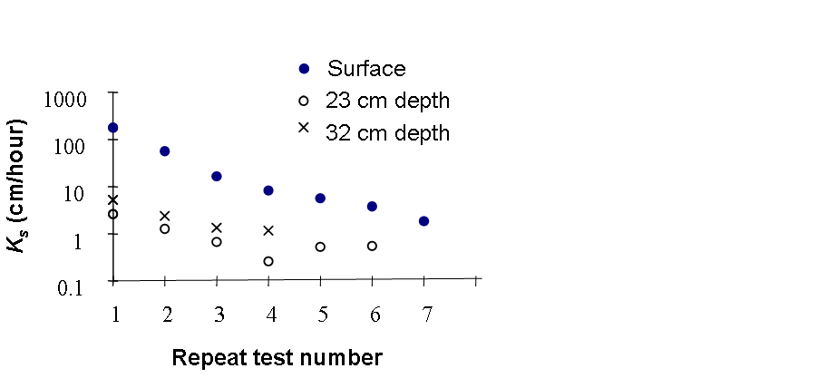

Figure 7a

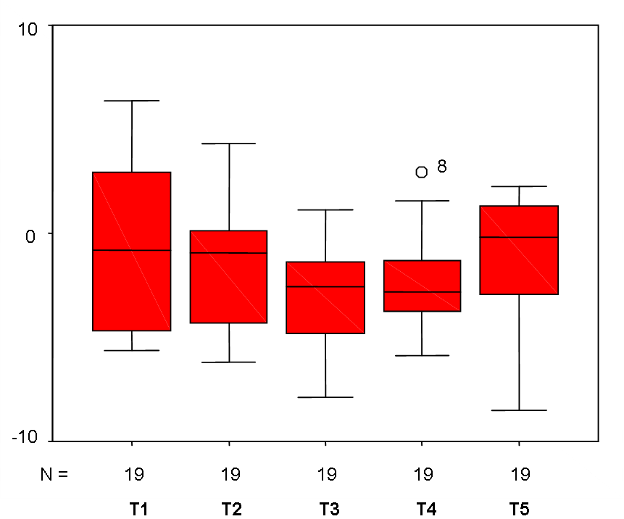

Figure 7b

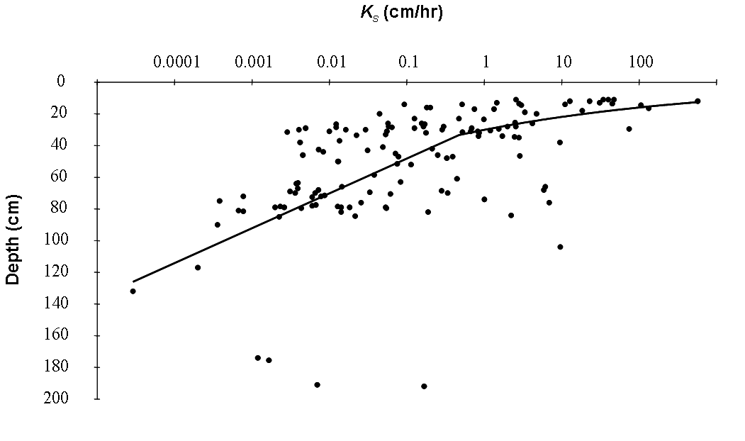

Figure 7c

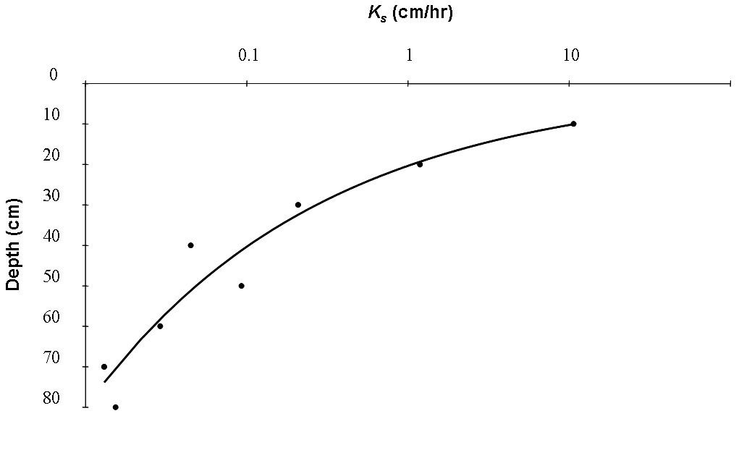

TABLES

Table 1. Comparisons of K_{s} values by different the borehole-based techniques
___________________________________

a. Estimates of saturated hydraulic conductivity (cm/hr) at two locations using different techniques

Piezometer number and depth Slug test CHBP FHBP
T1.1 at 14 cm depth 5.06 8.02 1.78
T1.2 at 28.5 cm depth 0.012 0.012 0.010

___________________________________________________________________________________

b. Ratio of slug test derived K_{s} to FHBP derived K_{s} estimates

Piezometer T1.1 T1.2 T4.2 T4.3 T5.10 T5.9 Geomean
Ratio 2.8 0.2 2.9 6.2 1.3 0.6 1.41

___________________________________________________________________________________

c. Ratio of CHBP derived K_{s} to FHBP derived K_{s} estimates
Piezometer T1.1 T1.2 T1.3 T1.4 T1.5 T1.6-s T1.6-30
Ratio 5.3 0.3 4.5 0.2 0.2 3.6 0.8

Piezometer T1.7-30 T1.7-S T1.8 T1.9 Geomean
Ratio 0.1 0.7 2.8 0.6 1.04
___________________________________

Table 2. Comparisons of statistical distributions of K_{s} values measured by different the borehole-based techniques

__________________________________

a. Tests for normality of datasets used in the comparison of measurement techniques: (i) Slug tests versus FHBP, and (ii) FHBP versus CHBP

(i) (ii)
Distribution K-S statistic Significance K-S statistic Significance
level level
FHBP 0.71 0.69 1.32 0.06
Slug test 0.86 0.45 1.51 0.02
ln(FHBP) 0.30 1.00 0.63 0.82
ln(slug test) 0.57 0.90 0.62 0.83
___________________________________________________________________________________

b. Results of F-tests and t-tests for comparison of slug and FHBP datasets
Distribution n test result critical value
F-test 6 4.75 5.05
t-test 6 0.34 2.23
___________________________________________________________________________________

c. Wilcoxon Signed-rank Test results from the comparison of different measurement techniques

Distributions n test result (W+,W-) critical value
Slug/FHBP 6 4, 17 1
CHBP/FHBP 13 46, 32 14
__________________________________

Table 3. Kolmogorov-Smirnov (K-S) test for normality for raw and transformed K_{s} data

____________________________________________________________________
Transformation K-S statistic Significance level
____________________________________________________________________
Raw 5.08 0.00
Ln 0.79 0.56
x^{1/2} 3.86 0.00
x^{1/3} 2.75 0.00
x_{1/4} 2.20 0.00
____________________________________________________________________

