Centre for Research on Environmental Systems and Statistics
_____________________________________________________________________

Danum Valley Rainforest Research and Training Programme

Trees in proximity to canopy access locations

CRES/QA/RS-CAN/1/0008/1.0

N.A. Chappell, B. Ola, M.J. Hanapi, S.A. Samat

Institute of Environmental and Natural Sciences
Lancaster University, Lancaster LA1 4YQ
United Kingdom

Commercial-in-confidence

Document Number: CRES/QA/RS-CAN/1/0008/1.0

Title: Trees in proximity to canopy access locations
(Danum Valley Rainforest Research and Training Programme)

Author(s) and
affiliation: N.A. Chappell (CRES), B. Ola, Mohd.J. Hanapi, and S.Abd. Samat (Yayasan Sabah)

Date written: August, 2000

Revised:

_____________________________________________________________________

Work carried out for the VOC-hydrology project

 | NAME | SIGNATURE | DATE
AUTHOR(S)
CHECKED
APPROVED
APPROVED FOR
EXTERNAL
DISTRIBUTION

Centre for Research on Environmental Systems and Statistics
Institute of Environmental and Natural Sciences
University of Lancaster
Lancaster LA1 4YQ

tel: 01524 65201 and fax: 01524 593985

N.A. Chappell, B. Ola, M.J. Hanapi, and S.A. Samat 2000. Trees in proximity to canopy access locations: Danum Valley Rainforest Research and Training Programme. CRES Technical Report CRES/QA/RS-CAN/1/0008/1.0, Lancaster University, UK.

Several trees in the vicinity of the Danum Valley Field Centre (117º48.75’ E and 5º01’ N) Sabah, Malaysian Borneo, have been equipped with wooden observation platforms at the tops of their stems. Some of these trees also have aerial walkways linking two or more platforms. Additionally, several self-supporting, observation towers have been built in the same region.

On the 15 August 2000 a survey of these canopy access locations was undertaken by Bernados Ola, Mohd Jamal bin Hanapi, Shaidih bin Abd Samat and Nick A Chappell. The principal objectives of this survey was an assessment of the genus/species of the trees (a) having branches that could be reached from the platform / walkway / tower / ladder, and (b) that might add to the local, volatile organic compound (VOC) levels in the canopy about the platform / walkway / tower. This assessment is required for the establishment of a new research project on the link between VOC emissions and Hydrology (Owen, James, Sinun, Bidin and Chappell 2000/2001 ' Effect of land-management and habitat water status on the volatile organic compound (VOC) emissions from tropical forest canopies'). Tree identification was undertaken by Mr Bernados Ola.

\c-access.doc

For colour photographs and updates, see http://www.es.lancs.ac.uk/rssea/canopy.htm

Canopy platform, Nature Trail (virgin forest)

→ Dimoocarpus longan (within 2 m reach)
trees with branches in the
vicinity of the 60 ft platform
(no branch access from top platform) 5.1 m  Polyalthia spp.
(small tree, cannot reach)
6.1 m

3 m  Shorea johorensis (no branch access)
→  (ladder)
Shorea johorensis
(cannot reach)
6.6 m (distance between trunk of trees)

→ Xanthophyllum (can reach from platform)

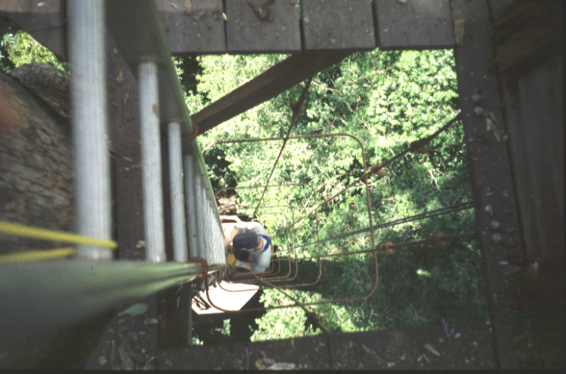

Figure 1. View down access ladder, Nature Trail platform

Observation tower, Nature Trail (virgin forest)

→ Walsura spp (large tree, cannot reach)

6.3 m

→ Memecylon spp (can reach)

3.3 m

Archidendron  3.6 m
jiringa (can reach)
2.4 m □ ⇦ 8.7 m 
Archidendron  Archidendron
jiringa (can reach) jiringa (large tree, can reach)
3.6 m

Archidendron 
jiringa (can reach)

(NB Can reach all trees from upper level, except Walsura spp)

Canopy platform, W6 (virgin forest)

 ⇦
Koompassia excelsa
(no branch access)

7.3 m 9.1 m

15.2 m

→ 
Aporusa spp Eugenia spp
(cannot reach from platform) (big tree; branch 6 m from
ladder, half way up)
→
Shorea johorensis
(cannot reach)

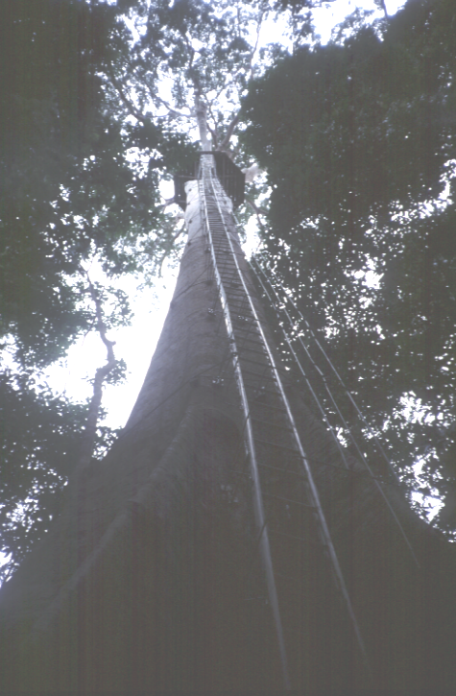

Figure 2. Canopy platform at W6

Canopy platform, C88 (logged forest)

Parashorea
mellaanonan Shorea oleasa

→ 

5.4 m 5.6 m

Mallotus spp 
Sindora irpicina
2.8 m (branches only 2-3 m away from ladder)
0.3 m 
⇨ Koompassia excelsa (no branch access)

4.7 m
4.3 m 4.3 m
→
Hopea nervosa  
(branches far) Xanthophyllum spp Alangium ebenaceum
5.1 m

→
Polyalthia spp

Canopy platforms / small walkway, FACE fire lookout (logged forest)

Lithocarpus spp
(branches reach to centre of walkway)

Lithocarpus spp Shorea spp 
→ (small tree upto first
platform, 10m)
→

4.7 m
4.62 m 5.7 m
Shorea pavifolia 
(small tree by ladder) 2.25 m
Shorea pilosa
Shorea multiflora ⇦ ⁼ ⁼ ^{5.6 m walkway = =} 1.45 m
1.8 m Shorea spp
→
Lithocarpus spp
(good access from both first
and second platforms)

(NB Planks on walkway need repairing; nails !)

→ Shorea spp (a long distance from tree)

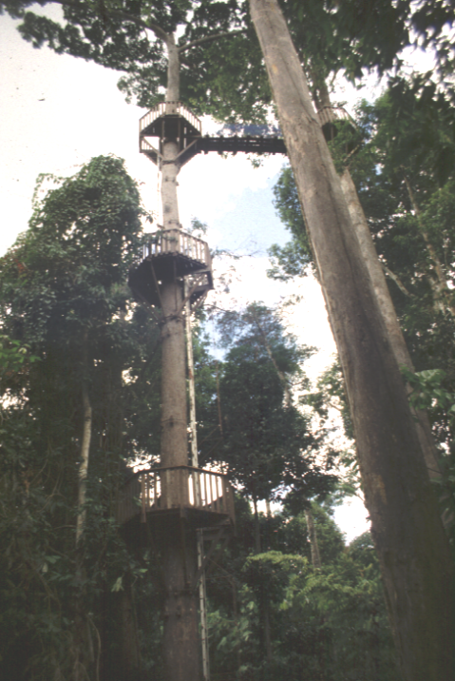

Figure 3. FACE fire lookout platforms and small walkway

Figure 4. Small walkway at FACE fire lookout

Canopy walkway, BRL (virgin)

→ Aglaia spp

→ Ryparosa spp (over first platform)

 3.9 m

Eugenia spp   Barrringtonia spp (over first platform)
→ 2-3 m  1.5 m
Fordia spp  1 m = = = ⇨ Shorea johorensis
(very small tree 
next to first platform) 
 3.7 m along walkway
  Barrringtonia spp (bigger tree)
  Archidendron jiringa



10.4 m along walkway 
Parashorea tomentella  2 m 
(+ lianas; good access) 





17.8 m along walkway 
Parashorea tomentella  3 m 
(+ 2x spp lianas)  … continued







 Shorea johorensis
25.1 m along walkway  (no branch access)
Blumeodendron tokbrai (good access)   3 m 
28.8 m along walkway 
Paranephelium spp (good access)   (NB the 3 left-hand trees extend branches
29.4 m along walkway  to right-hand side of walkway also)
Diospyros spp (good access)  



 38.8 m along walkway
Teijsmanniodendron pteropodum   = = =
(good access) Shorea johorensis

 = = =







38.2 m along walkway 
Eugenia app  6 m (2 m to any leaves !) 
43.5 m along walkway 
Shorea johorensis  7 m (2 m to any leaves !)
29.4 m along walkway  to right-hand side of walkway also)



65.4 m along walkway (from last Shorea  Pentace laxiflora (good access)
johorensis platform)  6 m 
→ 
Shorea superba (no access) Koompassia excelsa

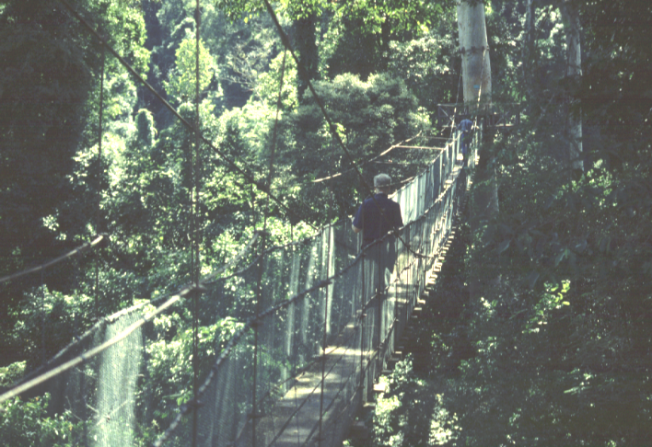

Figure 5. Last walkway section towards last platform, BRL

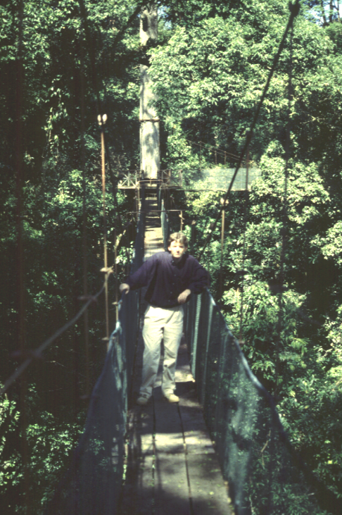

Figure 6. Last walkway section towards middle platform (from last platform), BRL

Observation tower, C89 (logged forest)

not surveyed

Observation tower, Bukit Atur (logged forest)

not surveyed

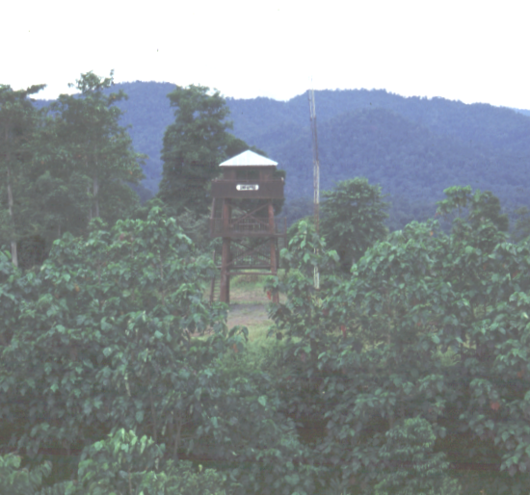

Figure 7. Observation tower, Bukit Atur

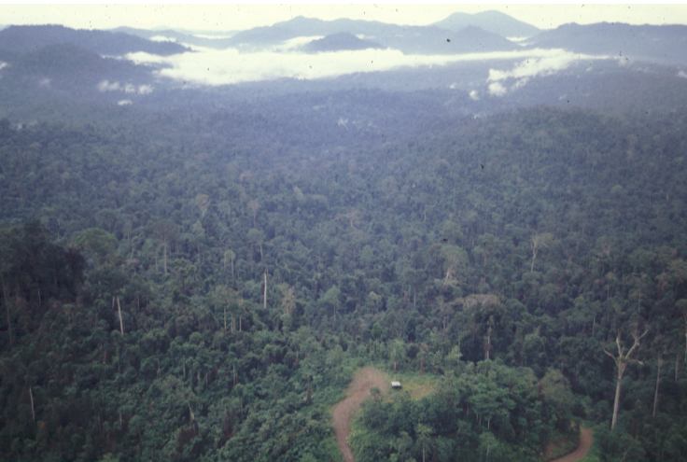

Figure 9. Bukit Atur prior to observation tower construction. Gunung Danum is the double peaked hill on the horizon

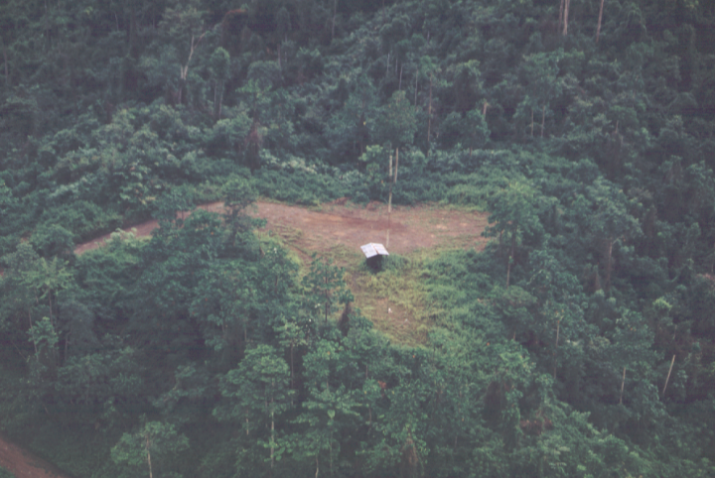

Figure 10. Bukit Atur prior to observation tower construction (old atur building shown)

NAC 31/8/00

Document Number: CRES/QA/RS-CAN/1/0008/1.0

Title: Trees in proximity to canopy access locations
(Danum Valley Rainforest Research and Training Programme)

_____________________________________________________________________

Distribution List

NAME AND AFFILIATION
Dr Nick A. Chappell (CRES, Lancaster University)
Mr Bernados Ola (Yayasan Sabah)

Dr Waidi Sinun (Secretary, Danum Valley Management Committee)

Dr Sue Owen, Prof Nick Hewitt and Dr Rob Mckenzie (Lancaster University)

The Royal Society S.E. Asia committee (c/o Chairman)

CHECKED BY: (Senior Officer)
DATE:

